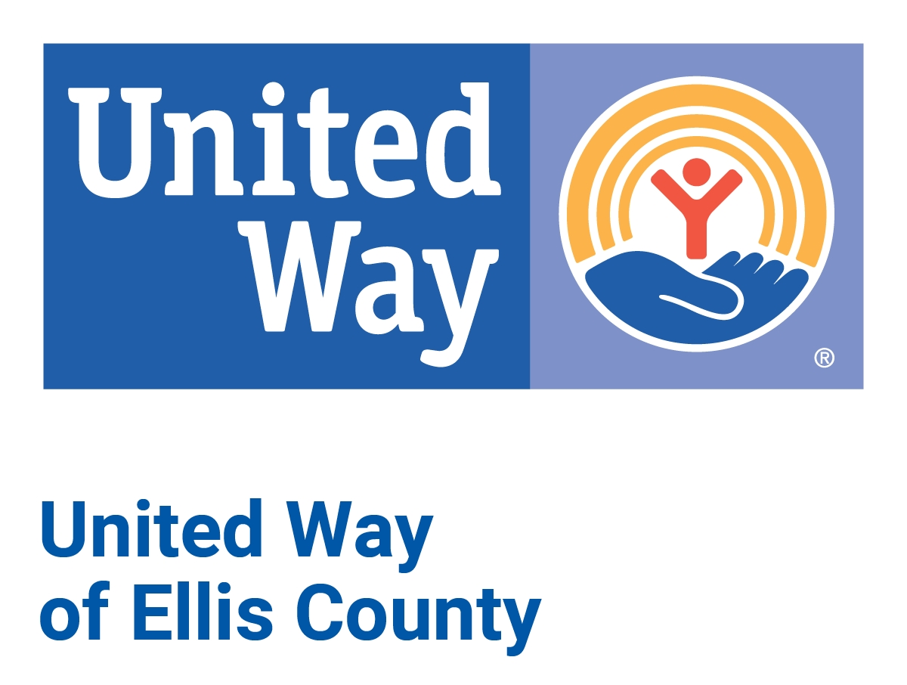
United Way of Ellis County Covid-19 Emergency Relief Fund
Micro Grant Application
Criteria: To qualify for funds from the “United Way of Ellis County Covid-19 Relief Fund”
- Your agency must be a 501(c)(3) organization.
- Your agency must be in good standing with the State of Kansas.
- Your agency must serve a majority of your clients from Ellis County.
Grant requests can be up to $500 and must be for Covid-19 prevention, education, or mitigation of the economic fallout.
Please forward grant applications to the attention of Erica Berges (uweced@ruraltel.net)
Name of Organization:
EIN #:
Person Submitting Request:
Contact Information:
Agency address:
Phone:
Email:
Website:
Date:
Agency Mission Statement:
Request Amount: $
Please state the nature of the request. How will United Way Funds be used by your agency to assist the community in the areas of Covid-19 prevention, education, or mitigation of the economic fallout?

*Please include a copy of your 501(c)3 if not a current United Way partner agency.
I agree to that our organization meets the stated criteria for this microgrant.

Signature of Agency Executive Director _______________________________________

